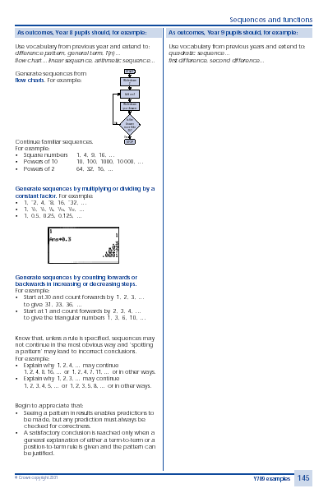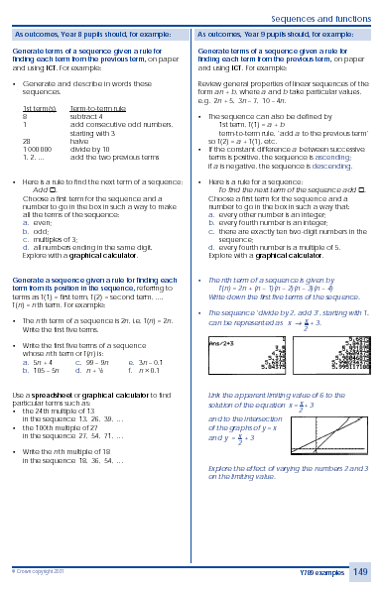
TEACHING & LEARNING OBJECTIVE:
Generate and describe integer sequences
Generate terms of a linear sequence using term-to-term definitions of the sequence
Year 8
Algebra

ORGANISATION

Whole-class:

The introduction to this activity could be done as a whole-class activity, using an OHP view-screen. Students could use individual white boards or number fans to predict what the next term in the sequence will be, extending to 10th term / 100th term.

Grouped:

The latter part of the activity sheet could be approached as a paired activity, with challenges for the first pair to ‘crack’ the rule each time.

Individual:

This activity sheet could be used as an activity for individuals, following a whole-class introduction.
Framework for teaching mathematics: Year 8

Page 145 / 149
GRAPHICAL CALCULATOR ACTIVITY

Generating SEQUENCES 2

Generating SEQUENCES 2

TEACHING & LEARNING OBJECTIVE:
Generate and describe integer sequences
Generate terms of a linear sequence using term-to-term definitions of the
sequence

Year 8

Algebra
This activity helps you to use a graphical calculator to generate number sequences. Each time, we will provide the calculator with a ‘start number’ and then describe the rule to find the next term in the sequence.

Since our rules will describe how to get from one term to the next, they are called ‘term-to-term’ rules.

To generate the sequence ‘start with 3 and multiply by two each time to find the next term’:

- Type in: 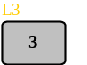

- Press .

To define the rule as ‘multiply by 2 each time’:

- Type in: 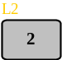

Now that you have defined the rule, each time you press the next term in the sequence will be displayed.

- Press twice.

The screen should now display the first three terms in your sequence:

- Use the calculator to generate the first ten terms in the above sequence.

- Without using the calculator, can you predict what the 100th term will be? Explain your reasoning.

- Find the first term and rule needed to generate the sequences:
  - 4, 12, 36, 108,....
  - 1, -2, 4, -8, 16,....
(c) 1, 0.5, 0.25, 0.125,....

- Here is a rule to find the next term in a sequence ‘Add ’. Choose a first term for the sequence, and a number to go in the box in such a way to make all of the terms in the sequence:
  - Even;
  - Odd;
  - Multiples of 3;
  - All numbers ending in the same digit.
In each case, explain and justify your answer.

- Given the rule ‘ Multiply by ’, can you suggest a first term for the sequence and a number for the box to generate sequences that still fit the criteria given above?

3
3
ANS*2
6
12

